- Watch the Terraform-03 video.
- Execute the script shown in the video.
Here I have created one file i.e: work.txt
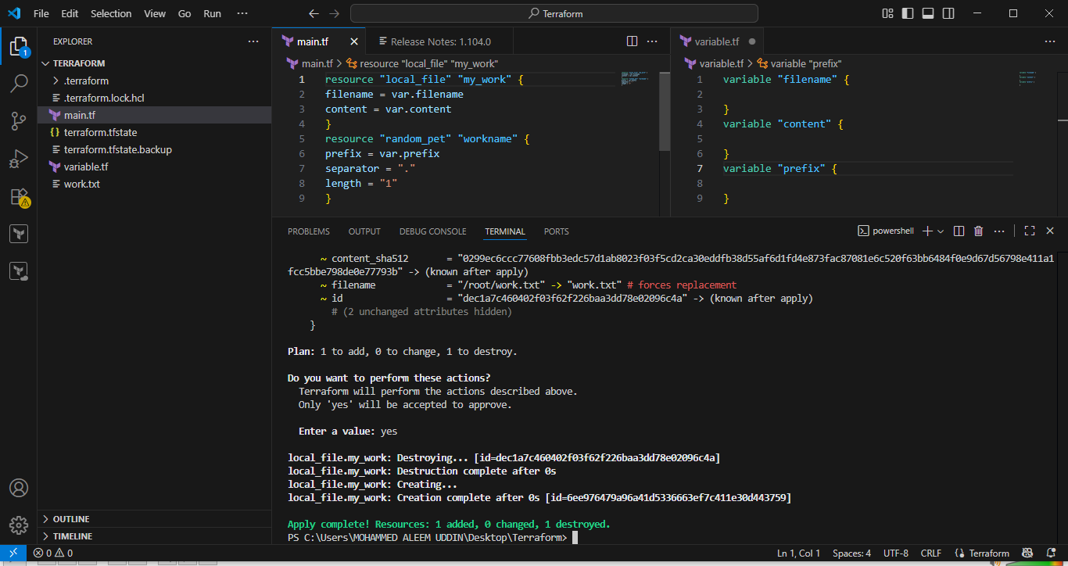
Here I have added content in the file work.txt
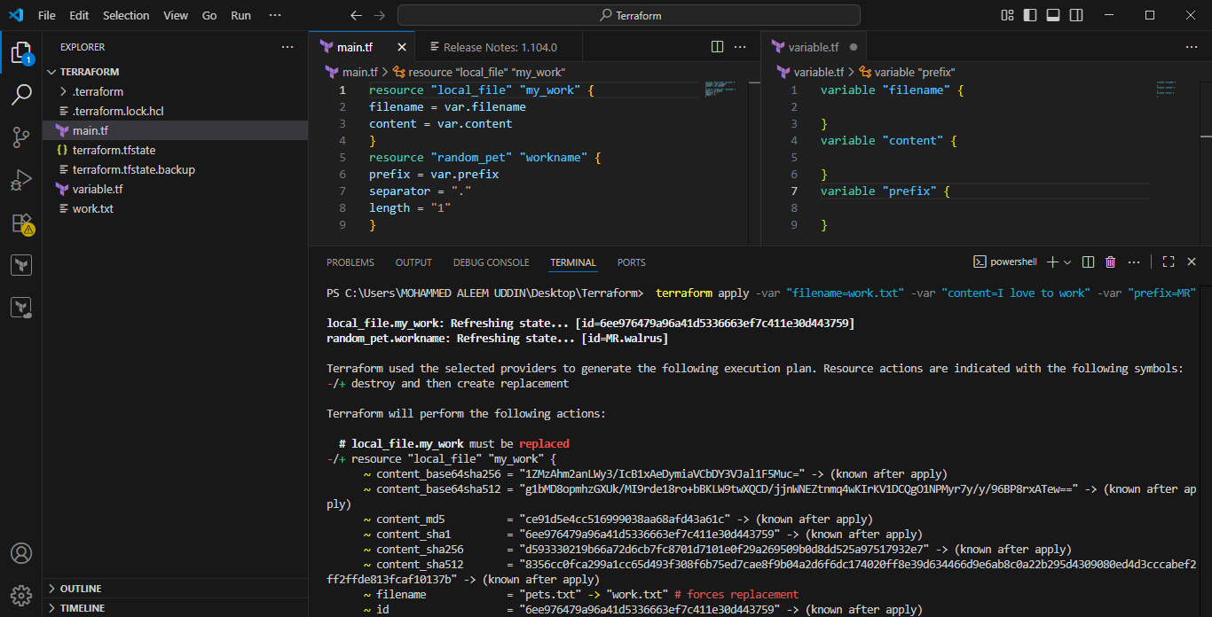
Here can see the content
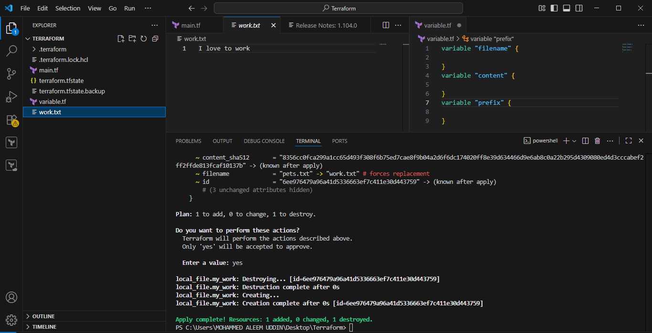
Here we have applied some environmental variable to .txt file, content and prefix.
Terraform utilizes environment variables to customize its behavior, set values for input variables, and configure various aspects like logging and backend settings. This allows for dynamic configuration without hardcoding sensitive or environment-specific values directly into Terraform configuration files.
Key uses of environment variables in Terraform:
- Setting Input Variable Values:
  - Terraform automatically recognizes environment variables prefixed with TF_VAR_ as values for declared input variables.
  - For example, if you have a variable named username in your Terraform configuration:
Code
variable "username" {
type = string
}
- You can set its value via an environment variable:
Code
export TF_VAR_username="myuser"
- Terraform will then use "myuser" for the username variable during execution.
- Controlling Terraform's Behavior:
  - Specific environment variables can modify how Terraform operates.
  - TF_LOG: Enables detailed logging output to stderr, useful for debugging. You can set it to TRACE, DEBUG, INFO, WARN, or ERROR for different verbosity levels.
  - TF_LOG_PATH: Specifies a file path where TF_LOG output should be written instead of stderr.
  - TF_INPUT: When set to false, it prevents Terraform from prompting for input variables that don't have a value specified elsewhere.
- Provider Credentials and Configuration:
  - Many Terraform providers (e.g., AWS, Azure, GCP) use environment variables to store authentication credentials or other provider-specific configuration details.
  - Refer to the specific provider's documentation for the exact environment variables it supports (e.g., AWS_ACCESS_KEY_ID, AWS_SECRET_ACCESS_KEY).
How to set environment variables:
- Linux/macOS: Use the export command in your shell before running Terraform commands.
Code
export TF_VAR_my_variable="some_value"
- Windows: Use the set command in your command prompt or configure them through the System Properties GUI.
Code
set TF_VAR_my_variable="some_value"
- Automation/CI/CD: Environment variables are commonly set within CI/CD pipelines or automation scripts to provide necessary values to Terraform runs.
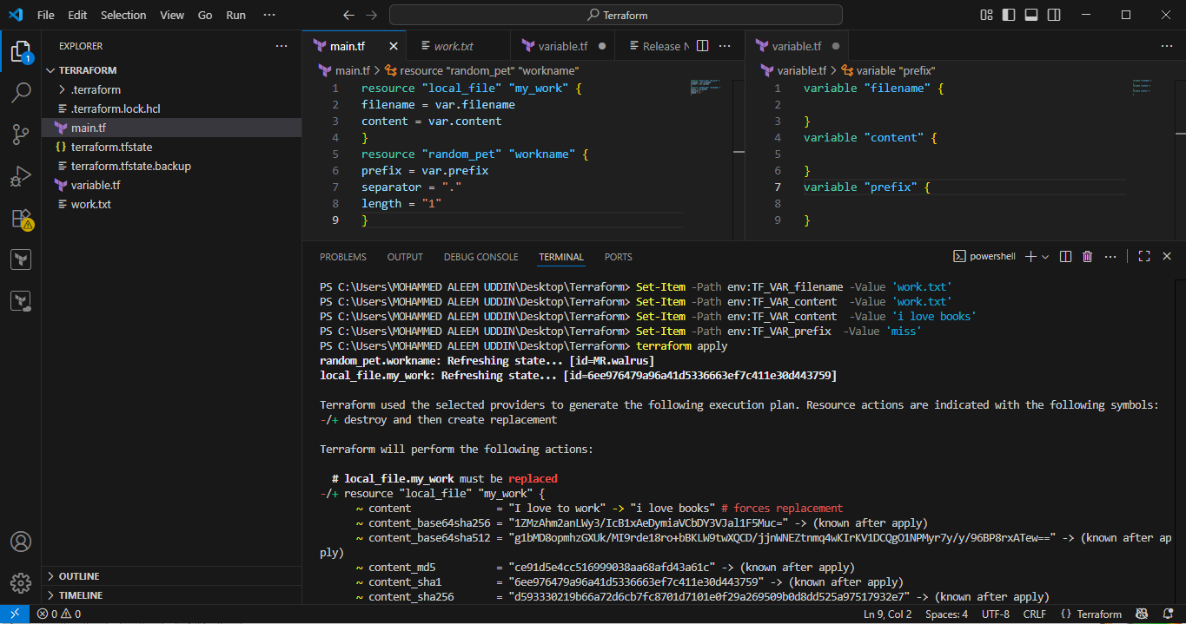
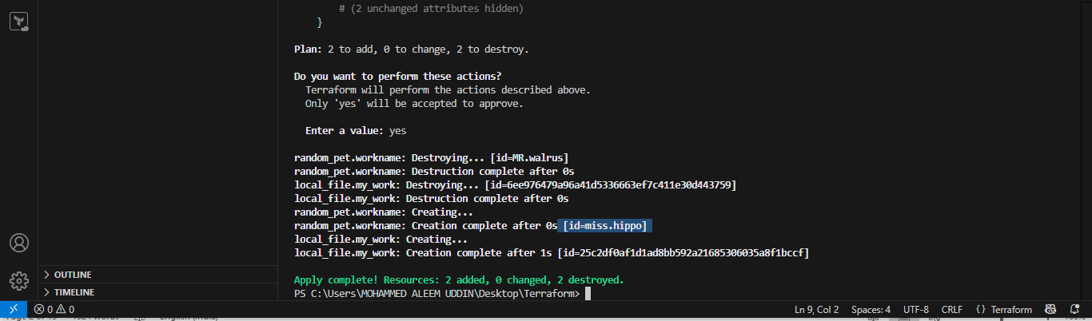
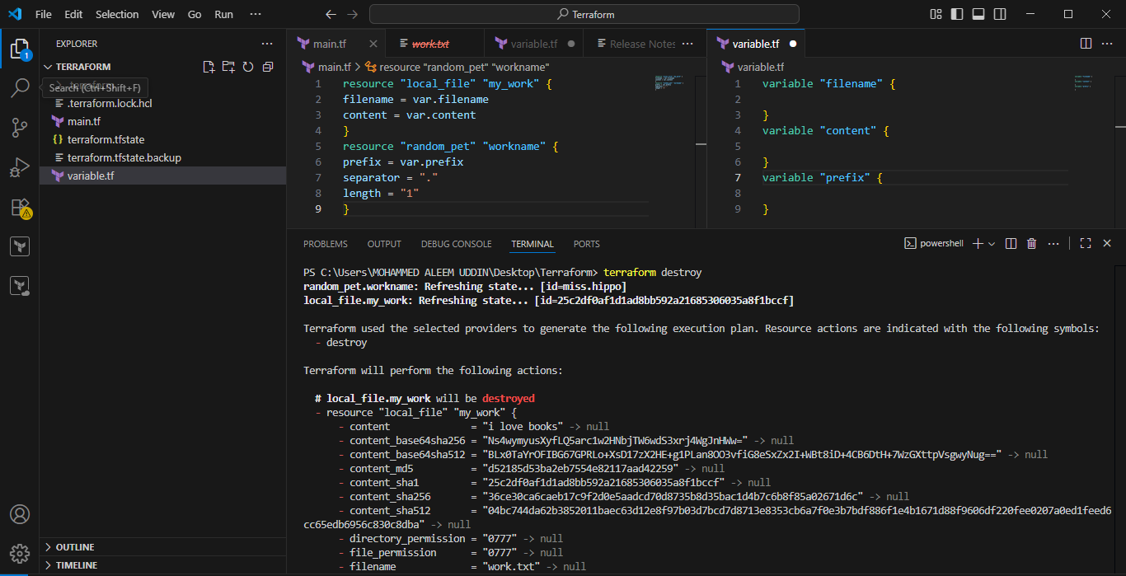
Here we have set the provider for in the content can see in the below pics.
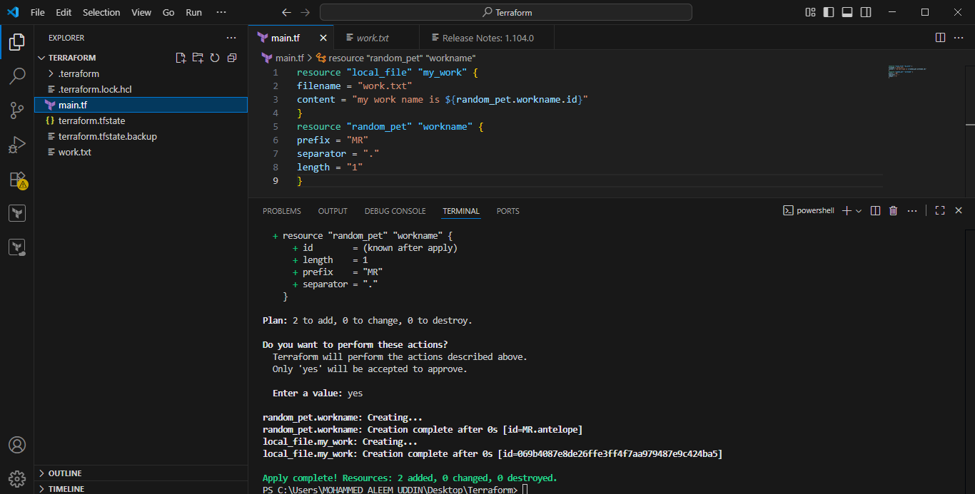
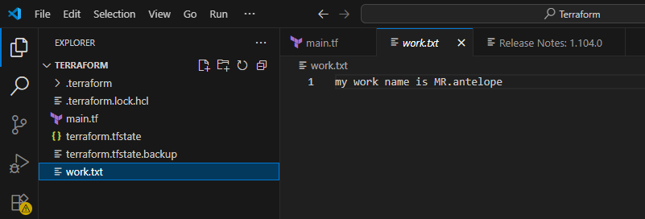

Here we have added one more provider output.
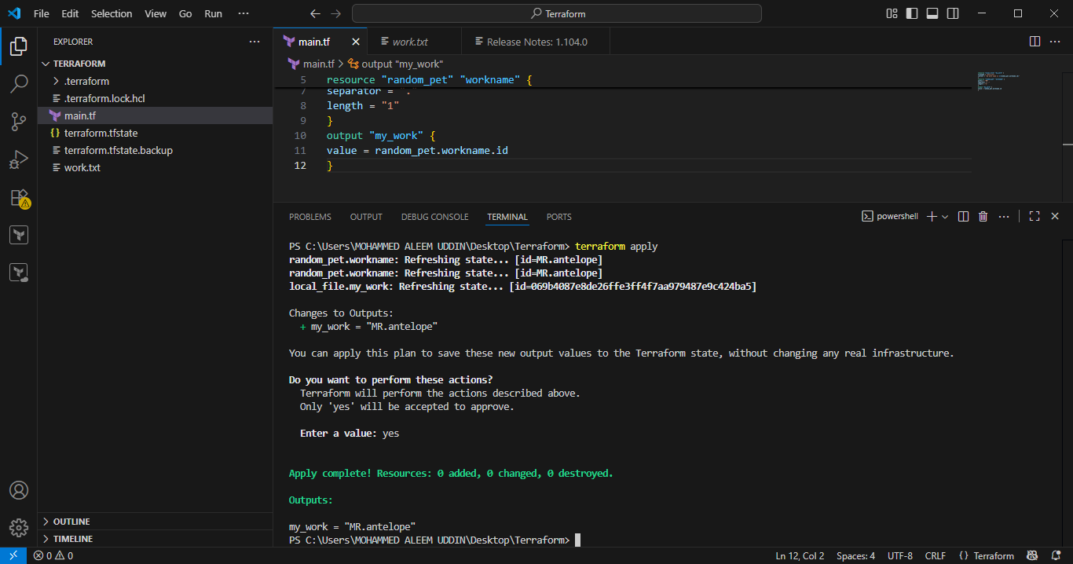
In Terraform, the concept of "outputting a provider" directly is not supported. Providers are global configurations within a Terraform workspace and are not treated as values that can be exported from a module using output blocks.
Instead of outputting a provider, you typically output the configuration details necessary to configure a provider in a different context.
For example, if a module creates an AWS IAM role and you need another module or root configuration to use that role to configure an AWS provider, you would output the ARN of the IAM role, not the AWS provider itself.
Here's why and what to do instead:
- Provider Scope:
Provider configurations in Terraform are designed to be global to the configuration, meaning they are defined once and then implicitly or explicitly used by resources and modules throughout that configuration. They are not intended to be passed around as data.

The terraform output command is used to extract and display the values of output variables defined within a Terraform configuration. These output variables serve as a mechanism to expose specific pieces of information about the infrastructure managed by Terraform, making it accessible to users, other Terraform configurations (like parent modules), or external systems.
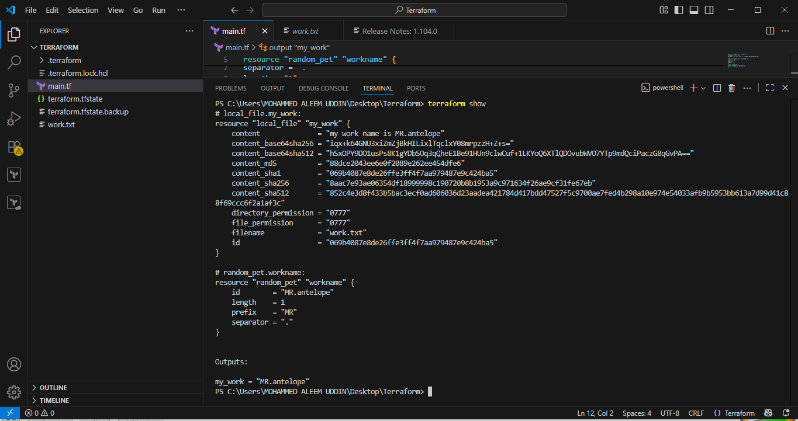
The terraform show command provides a human-readable output of either a Terraform state file or a Terraform plan file. Its primary uses are:
- Inspecting the Current State:
When run without any arguments or with the path to a state file, terraform show displays the current state of your managed infrastructure as Terraform understands it. This includes details about resources and their attributes.
- Inspecting a Plan File:
When run with the path to a plan file (generated by terraform plan -out=tfplan), terraform show displays the proposed changes that Terraform intends to make. This allows for verification of the planned operations before applying them.
Key Features and Options:
- JSON Output:
The -json flag can be used to generate machine-readable JSON output, which is useful for programmatic consumption and integration with other tools.
- Sensitive Data:
Be aware that when using the -json flag, any sensitive values in the Terraform state will be displayed in plain text. Refer to the documentation on managing sensitive data for more information.
- No Color:
The -no-color flag can be used to disable colored output, which can be useful when redirecting output or for specific automation scenarios.
- File Path:
You can specify a path to either a state file (e.g., terraform.tfstate) or a plan file to explicitly indicate which file to inspect. If no path is provided, it defaults to inspecting the current state.
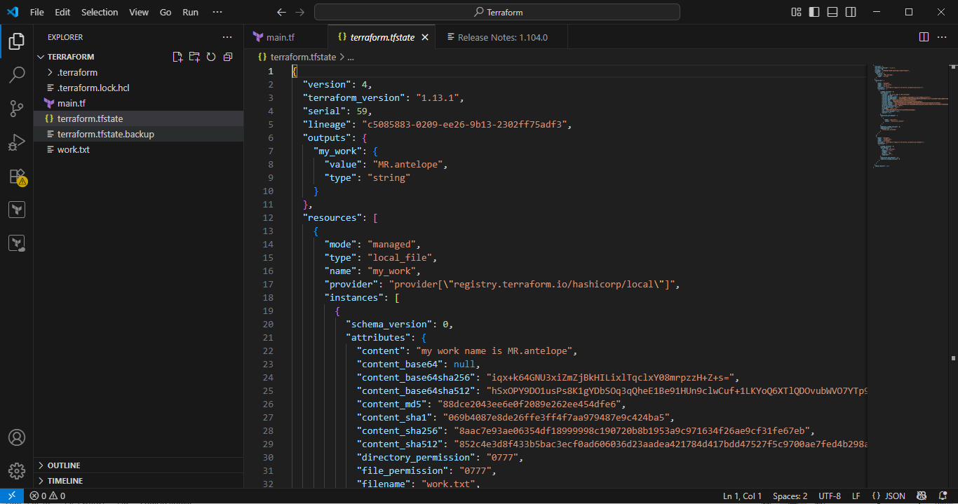
- Integrate Terraform in Jenkins using the Terraform plugin.
Jenkins master ec2 need installations below:
sudo yum install -y yum-utils shadow-utils
sudo yum-config-manager --add-repo https://rpm.releases.hashicorp.com/AmazonLinux/hashicorp.repo
sudo yum -y install terraform
1. Install Jenkins and Terraform Plugin:
- Ensure Jenkins is installed and operational.
- Install the "Terraform" plugin through the Jenkins Plugin Manager (Manage Jenkins > Manage Plugins > Available plugins).
2. Configure Terraform Installation in Jenkins:
- Navigate to Manage Jenkins > Global Tool Configuration.
- Scroll to the "Terraform" section and add a new Terraform installation.
- You can choose to install automatically (Jenkins downloads a specific version) or point to an existing Terraform binary if installed manually.
3. Prepare your Terraform Code:
- Create a Git repository containing your Terraform configuration files (e.g., main.tf, variables.tf, outputs.tf).
- Include a Jenkinsfile in the root of your repository to define the Jenkins pipeline stages.
4. Create a Jenkins Pipeline Job:
- In Jenkins, create a new "Pipeline" job.
- Configure the job to use "Pipeline script from SCM" and point it to your Git repository and the Jenkinsfile.
5. Define the Jenkinsfile:
The Jenkinsfile will orchestrate the Terraform workflow. A basic example for applying a Terraform configuration might look like this:

Jenkins file:
pipeline {
agent any

environment {
TFVARS = 'environment.tfvars' // change only here if you rename file
}

stages {
stage('Checkout Code') {
steps {
git branch: 'main', url: 'https://github.com/ALEEMUDDIN138/Terraform.git'
}
}

stage('Terraform Init') {
steps {
sh 'terraform init'
}
}

stage('Terraform Plan') {
steps {
script {
if (fileExists(env.TFVARS)) {
sh "terraform plan -var-file=${env.TFVARS}"
} else {
sh "terraform plan"
}
}
}
}

stage('Terraform Apply') {
steps {
script {
if (fileExists(env.TFVARS)) {
sh "terraform apply -auto-approve -var-file=${env.TFVARS}"
} else {
sh "terraform apply -auto-approve"
}
}
}
}
}
}
Main.tf:
resource "local_file" "my_work" {
filename=var.filename
content=var.content
}
Variable.tf:
variable "filename" {
description = "The name of the file"
type = string
default = "book.txt"
}

variable "content" {
description = "The content of the file"
type = string
default = "Hello from Terraform!"
}
Environment.tfvars:
resource "local_file" "example" {
filename = "book.txt"
content = "pages"
}
- agent any: Specifies that the pipeline can run on any available agent.
- Checkout: Clones your Terraform repository. Replace your-git-credentials-id and your-terraform-repo-url with your specific details.
- Terraform Init: Initializes the Terraform working directory.
- Terraform Plan: Generates an execution plan and saves it to tfplan.
- Terraform Apply: Applies the planned changes. -auto-approve bypasses interactive confirmation.
6. Run the Jenkins Job:
- Save the Jenkins job configuration.
- Manually trigger a build or configure a SCM polling or webhook trigger for automated builds upon code changes.
This setup enables Jenkins to automate the execution of your Terraform templates, facilitating CI/CD for your infrastructure.
Create job and configure as below:
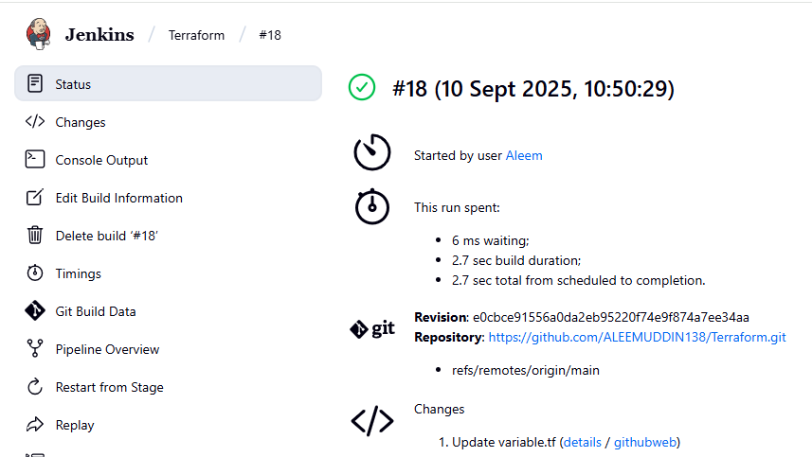
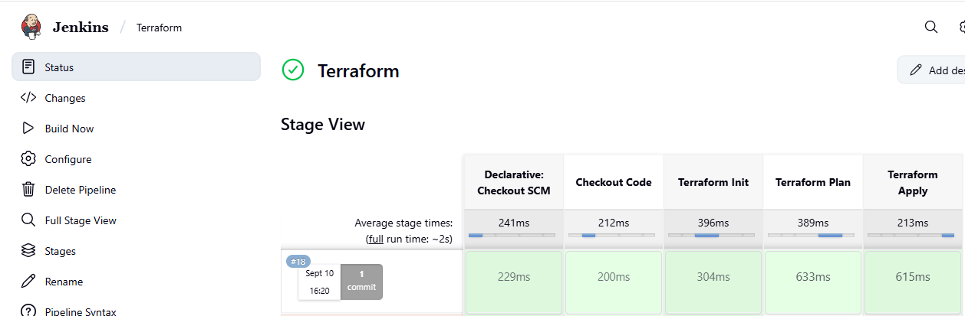
Here we can see the content of the .txt file.
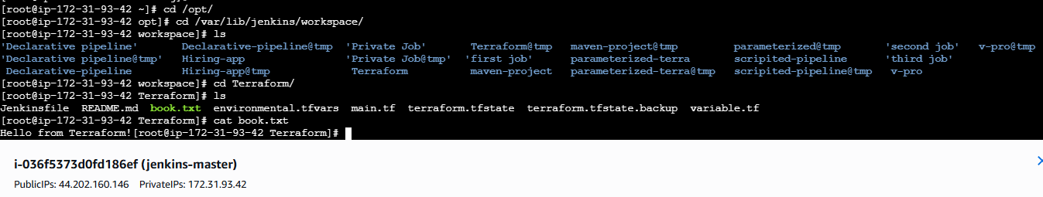
- Create one Jenkins job using Maven Project for the code below with two stages:
  - Stage 1: Git clone
  - Stage 2: Maven Compilation Code: https://github.com/betawins/java-Working-app.git

A — Prerequisites (do these first)
- Jenkins running and you can log in as administrator.
- Install necessary plugins if not already present: Git Plugin, Maven Integration plugin (and optionally Pipeline if you want pipeline later).
  - Jenkins → Manage Jenkins → Manage Plugins → Available → search & install.
- Make sure Git is available on the Jenkins host (or configure Git in Jenkins tools).
  - On Ubuntu/Debian: sudo apt install git -y
  - On RHEL/CentOS: sudo yum install git -y
- Install Maven on the Jenkins host or configure a Maven installation in Jenkins:
  - System install (Debian/Ubuntu): sudo apt install maven -y
  - Or in Jenkins: Manage Jenkins → Global Tool Configuration → Maven → Add Maven installation → Give it a name (e.g. MVN_HOME) and either auto-install or point to the installation path.
- (Optional) Configure JDK in Manage Jenkins → Global Tool Configuration if your builds need a specific JDK.

B — Create a Maven Project job (classic job) — Step by step
- Create job
  - Jenkins Dashboard → New Item
  - Enter name: e.g. maven-java-working
  - Choose Maven project (not Pipeline), click OK.
- Source Code Management (Git)
  - Under Source Code Management, select Git.
  - Repository URL:
https://github.com/betawins/java-Working-app.git
  - Branch Specifier: */main (if repo uses main). If repo uses master put */master. If unsure, check the repo on GitHub and use the correct branch.
  - If the repo is private, add Credentials (username/password or personal access token).
- Build (Maven)
  - Root POM: pom.xml (default; change if the POM is in a subfolder)
  - Goals and options: clean compile
(This runs Maven and compiles the project — change to clean install if you want to build artifacts.)
  - Maven Version: choose the Maven installation name you configured in Global Tool Config (e.g. MAVEN_HOME).
  - (Optional) in Build Environment you can check Provide Node & Environment or set environment variables.
- Build Triggers (optional)
  - e.g. Select Poll SCM with schedule H/5 * * * * or configure GitHub hook for push triggers (requires GitHub plugin / webhook).
- Post-build Actions (optional)
  - You can add Archive the artifacts e.g. target/*.jar or target/*.war if you want to keep the built artifact.
  - Add Slack/email notifications as required.
- Save the job.
- Build Now
  - Click Build Now.
  - Click the build number → Console Output to watch status.
Note: Classic Maven Project jobs don’t show Jenkins Pipeline-style stages in the UI. The job will run the Git checkout and then the Maven goal. If you want visible “stages” in the Blue Ocean / pipeline view, use a Pipeline job — see the scripted pipeline below.

C — Example Console flow you should see
- Git clone step: checkout of main/commit message.
- Maven compile step: Running mvn clean compile and then BUILD SUCCESS or BUILD FAILURE.
If mvn: command not found, you need to configure Maven as in Prerequisites.
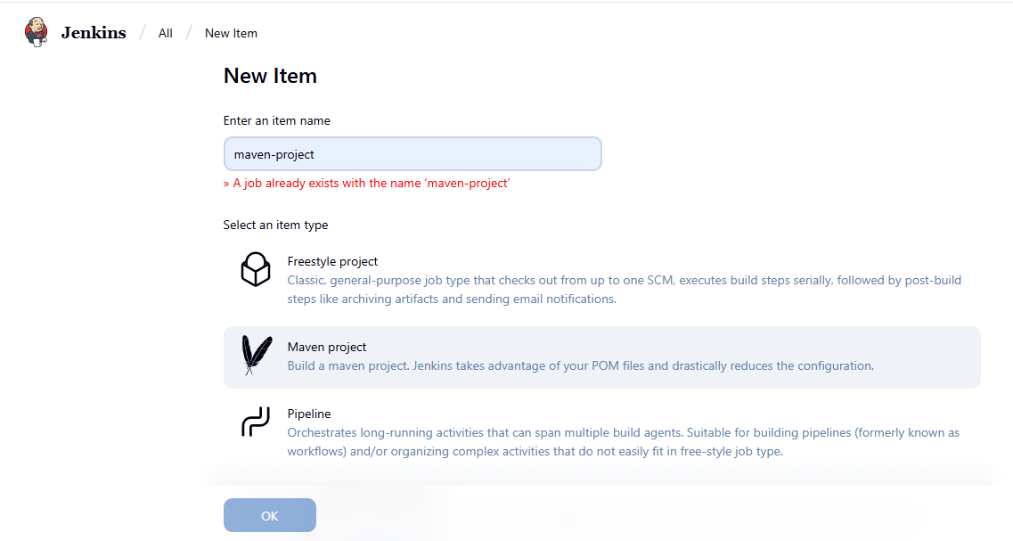
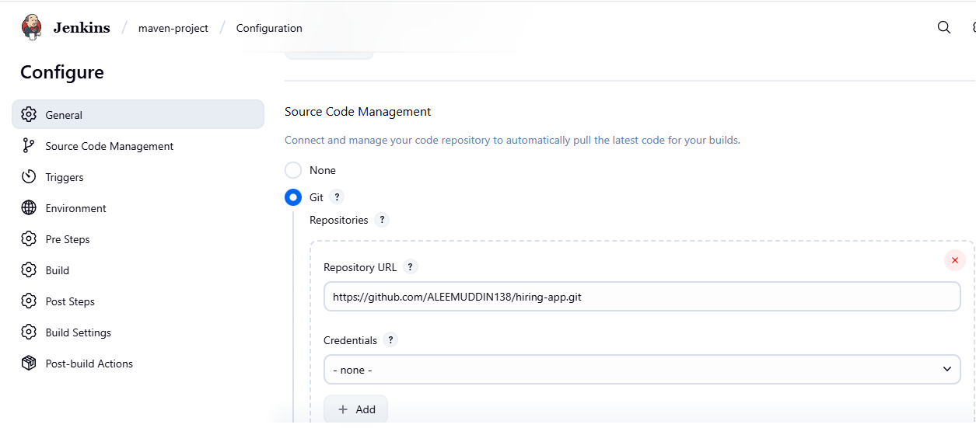

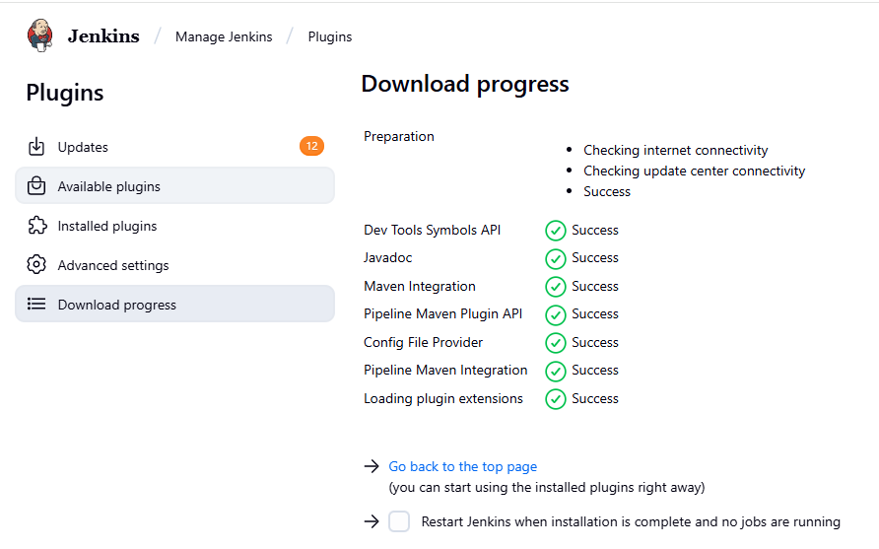
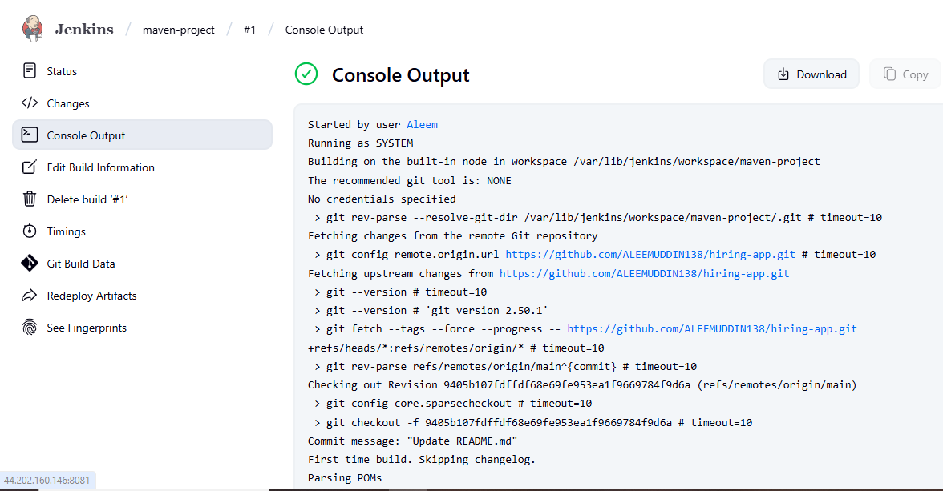
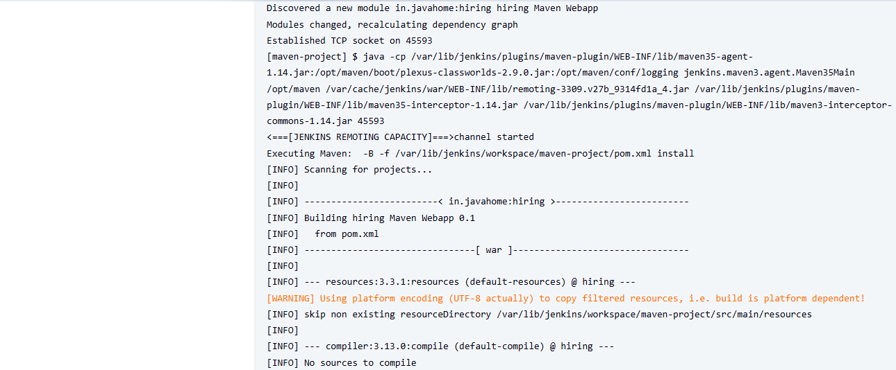
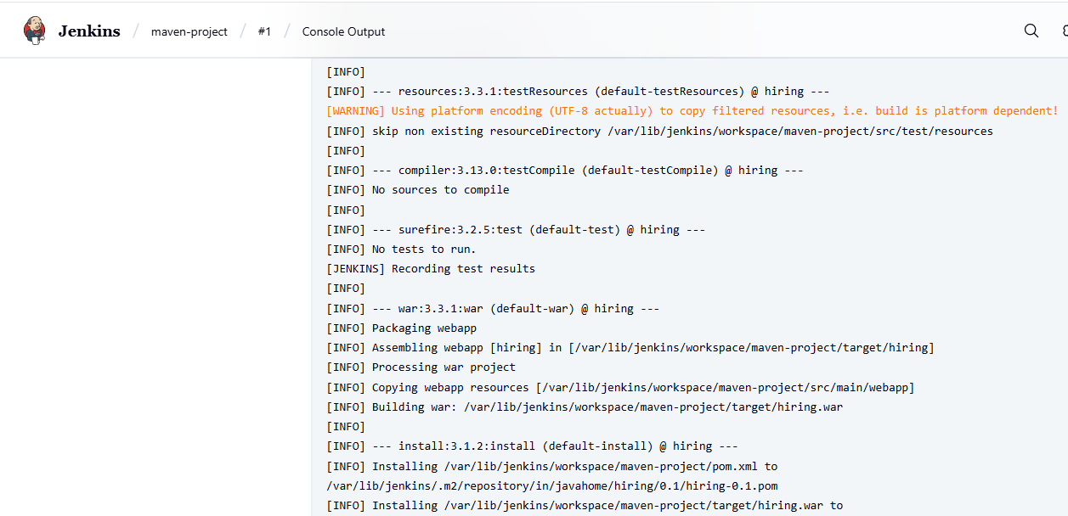
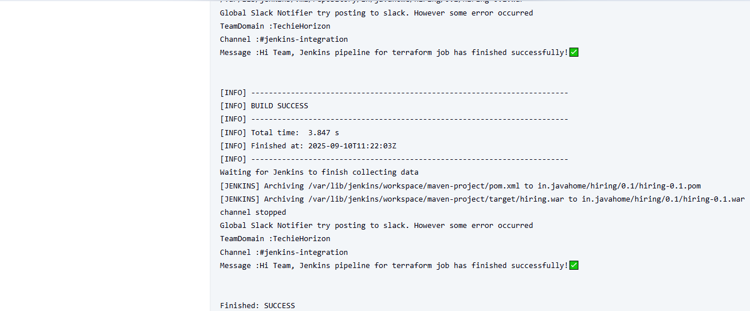

Now we can see maven created package in the local machine. (Target in the below pic)
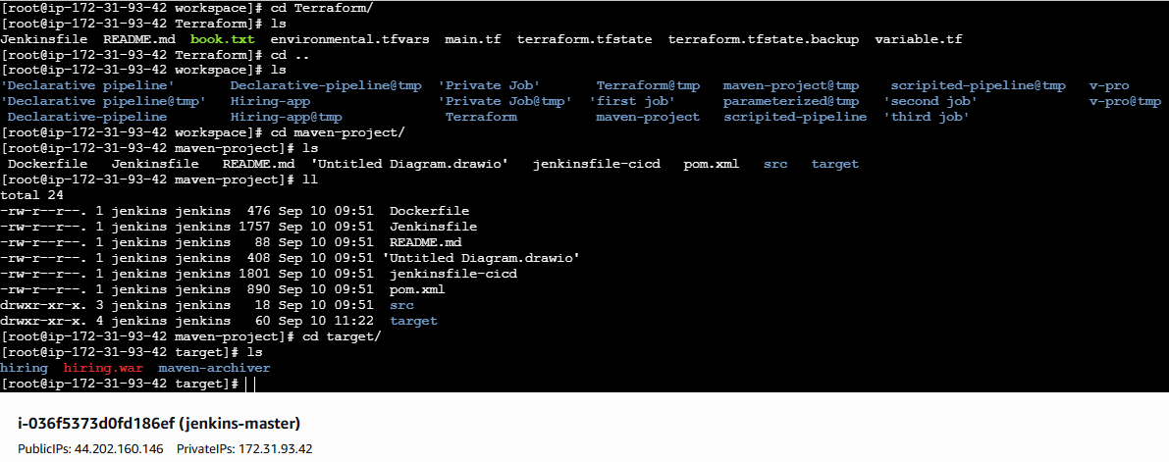
- Use the same code and create a parameterized job in Jenkins with:
  - Stage 1: Git clone
  - Stage 2: Maven Compilation Code: https://github.com/betawins/java-Working-app.git
Jenkins → New Item → name → Pipeline → OK.
Check This project is parameterized and add parameters:
- BRANCH (String) default main
- MAVEN_GOALS (String) default clean compile
- MAVEN_TOOL (Choice) choices MAVEN_HOME (or your tool name)
- SKIP_TESTS (Boolean) default true
Pipeline → Definition: Pipeline script → paste the script below.
Save → Build with Parameters.

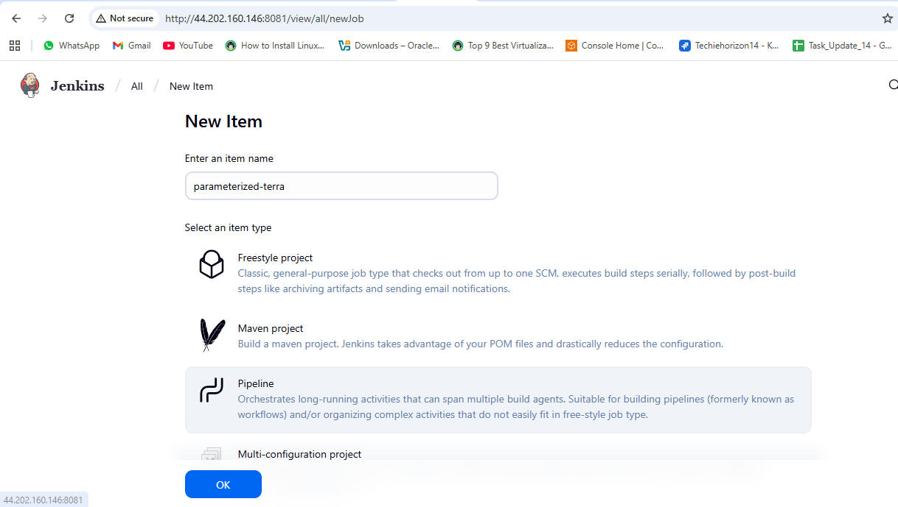
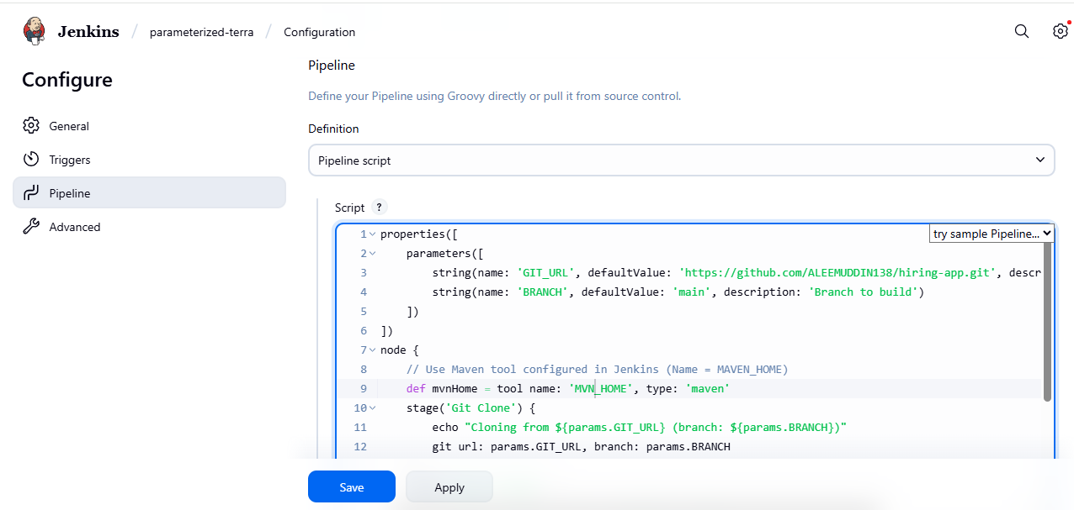
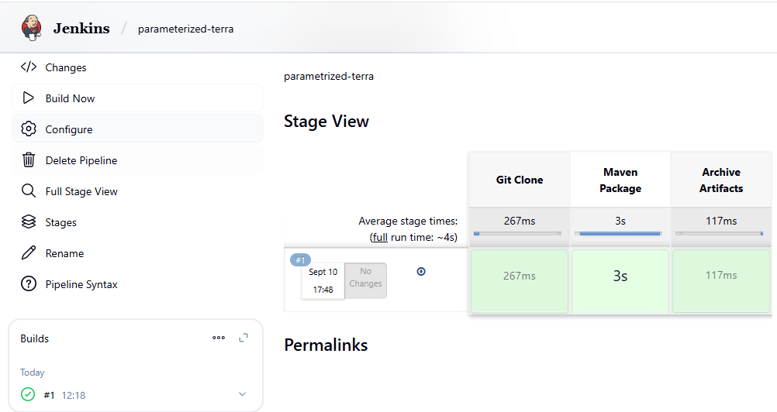
Here we can see the Maven package and Archive artifacts
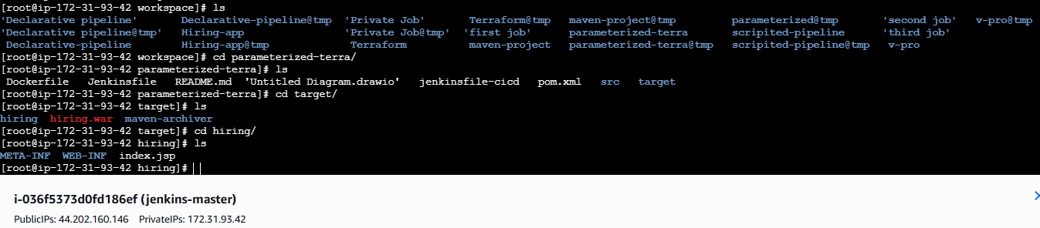
- What are the global variables in Jenkins?

Jenkins, Global Variables are the predefined variables that Jenkins makes available automatically in every pipeline or freestyle job. Global variables in Jenkins are the built-in variables (like env, params, currentBuild, and system environment variables) that Jenkins provides automatically to every job. They let you easily fetch job details, control pipeline flow, and configure environments without extra setup.There are 3 types of global variable in Jenkins.

Jenkins Global Variables & Usage Examples
Variable | Description | Pipeline Example
env.BUILD_NUMBER | Current build number | echo "Build #${env.BUILD_NUMBER}"
env.BUILD_ID | Same as build number, but formatted for scripts | echo "Build ID: ${env.BUILD_ID}"
env.BUILD_TAG | Unique build tag (job-name-build#) | echo "Tag: ${env.BUILD_TAG}"
env.BUILD_URL | URL of the build | echo "URL: ${env.BUILD_URL}"
env.JOB_NAME | Full job name (folder/jobname) | echo "Job Name: ${env.JOB_NAME}"
env.JOB_BASE_NAME | Last part of job name (without folder) | echo "Base Name: ${env.JOB_BASE_NAME}"
env.JOB_URL | URL of the job | echo "Job URL: ${env.JOB_URL}"
env.WORKSPACE | Workspace directory path | echo "Workspace: ${env.WORKSPACE}"
env.NODE_NAME | Name of node/agent | echo "Node: ${env.NODE_NAME}"
env.EXECUTOR_NUMBER | Executor number on agent | echo "Executor: ${env.EXECUTOR_NUMBER}"
env.GIT_COMMIT | Git commit hash (if Git plugin used) | echo "Commit: ${env.GIT_COMMIT}"
env.GIT_BRANCH | Git branch name | echo "Branch: ${env.GIT_BRANCH}"
env.JENKINS_HOME | Jenkins master home directory | echo "Jenkins Home: ${env.JENKINS_HOME}"
env.JENKINS_URL | Jenkins server URL | echo "Server URL: ${env.JENKINS_URL}"
params.<PARAM_NAME> | Access build parameter value | echo "Selected Branch: ${params.BRANCH}"
currentBuild.number | Current build number | echo "Build #: ${currentBuild.number}"
currentBuild.result | Current build result (SUCCESS/FAILURE) | echo "Result: ${currentBuild.result}"
scm | Refers to SCM configuration | checkout scm

